Enthalpy Prediction for the Rotokawa Geothermal Well Field using Classification Models

CSCI 568

Matthew Minnick

Bao Nguyen

# Introduction

A data set of geothermal well properties for the Rotokawa Geothermal field was chosen as the focus of this data mining project. The Rotokowa Geothermal Field is located about 10 km north-east of Taupo Township in the eastern part of the Taupo Volcanic Zone on the New Zealand North Island. The field extends over and area of 17 to 28 sqkm, and is comparable to other successfully exploited geothermal fields used to generate electricity. Wells are drilled into the geothermal reservoir to inject water and extract the heated pressurized water to power electric generators. There is currently a power plant nearing completion at Rotokawa. The plant needs enough energy production from the wells to run the turbines. Currently there is not enough energy, measured in enthalpy (kj/kg), being produced from the production wells to run the power plant. More production wells will be needed at Rotokawa to produce the required enthalpy. The current wells are approximately 3 km deep and cost upwards of 2 million NZ dollars a well to install. It is important to understand the geothermal reservoir and the spatial distribution of the highest enthalpy values to optimize the installation of additional production wells.

There are currently 27 wells drilled in the Rotokawa field which have associated data sets that can be used to model the subsurface. The data classes include x, y, z spatial data, a well ID, geology or rock type represented by a integer, and measured temperature, infectivity, flow, and enthalpy values.

The measured values are taken at various intervals along the well bores are not complete for all the wells. The enthalpy measurements are the most sparse of the measured classes and one of the most important in modeling the well field. An initial 3-D model was built of the geothermal well field using Kriging methods to interpolate the data, figure 1. The uncertainty of the interpolated results is very high due to the lack of enthalpy measurements available. This presents a problem that lends itself to the use of various data mining techniques to supplement the data set with predicted enthalpy values.

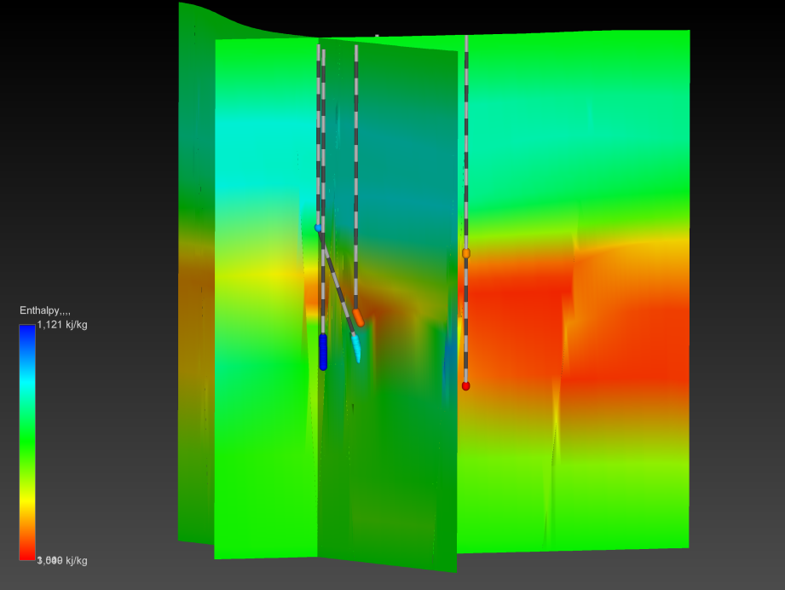Project Objective: Predict enthalpy values for missing data intervals using Classification models with existing data classes and compare to measured data sets in the 3-D model.

Figure 1. Cross sections of interpolated enthalpy values and well bore samples generated from the measured values using 3-D Kriging.

# Data Pre-Processing

The original data sets were given to us from Mighty River Power Corp. in Hamilton, New Zealand. The data sets are in excel spreadsheets in the project folder, "All_Wells_pgf .xlsx" (geology data), "Temperature_xyz.xlsx", and "Flow and Enthalpy XYZ.xlsx". To analyze the data all the attributes for the wells from the various data files needed to be combined into one data file. It is important to correctly combine the data based on the x, y, z values for the measured data intervals. Temperature values were converted to a continuous data set using a quadratic prediction equation from a regression fit, figure 2. It was also decided to remove the flow values from the data set. This was done due to the missing flow values compared to the more complete injectivity values and the correlation between flow and injectivity which can be seen in the scatter plot comparing the different classes to enthalpy, figure 3. The resulting combined data set is given in "Data_processed.xlsx". This combined data set then became the master table to create a training and test data sets for classification models.

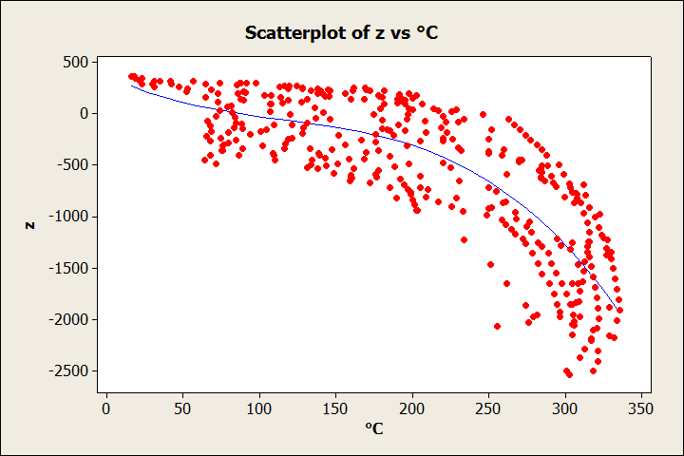

Figure 2. Scatter plot of measured temperature values vs. depth (Z) and resulting regression curve used to calculate continuous temperature values for the combined data set.

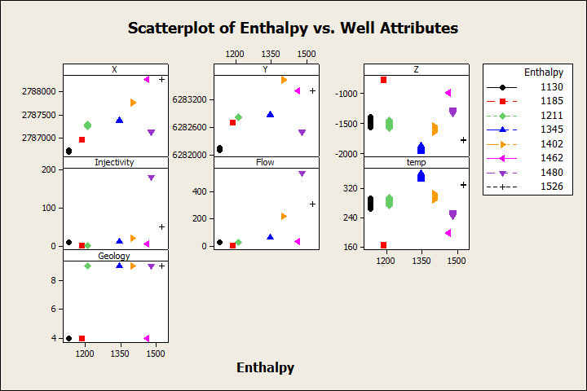

Figure 3. Scatter plots of data classes versus the enthalpy class. Note close correlation of injectivity and flow to Enthalpy.

# Classification Models

We decided to use WEKA as our main data mining tool. Since we wanted to do predictions of what the Entropy will be, we thought that classification would be the best way to determine the missing entropy data. Before running the classification, we split the data set into two main sub-data sets. One file would contain all the data that does not have any missing values including the Entropy. This file will be use as the training data set for creating the classification models. The other sub-set which contains missing values for the Entropy attribute would be use as the prediction set. We would run this file through the created classifier and predict what the Entropies are and compare them to the 3D modeling prediction.

While looking through the data we saw that some of the data also have missing flow values, which could make the classification less accurate. But after looking at the data for a while we noticed that the flow was highly correlated with the injectivity values. The flow values only change when the injectivity values change. The same injectivity value for any data point would have the same flow values. So from this we determine that the flow would not give us and new data as long as we have the injectivity data. We decided to remove the flow attribute reducing the number of attributes that needed to be classify. This also remove the only other attributes with missing values in the data set, which we believe would make the classification more accurate.

Using the Explorer in WEKA we loaded the training data set and did a little bit more preprocessing. Since classification are done on nominal attributes, we use the NumericToNominal filter to transform the Entropy, Geology and Well attribute to nominal. The Entropy attribute needed to be nominal for classification purposes, the other two attributes have nominal values but WEKA made it numeric so they were change to nominal as well. We than took the training data set and ran a few classification on it. We didn’t know which classification technique would be the best for our data set so we decided to use a few different ones and test which give us the better model. Since our data set isn’t very large this was possible to do in the time that we had to do the project. The classifiers that we decided to use were J48 tree, NBTree, NaiveBayes, Multiple Preceptron (ANN), NNge, DecisionTable and the ZeroR classifier.

For all of the classifier we use the cross validation method to test the models created. A 5 fold cross-validation was use since there were approximately 100 data points so this would allow each fold to have 20 values. We believe that training on 80 data points and than testing the model with 20 values would be good enough. For the J48 classifier we use a confidence of 0.25 and minimum number of object as 2. We chose 10 hidden layers for the ANN with a learning rate of 0.3 and a momentum of 0.2. We had the the ANN train for 500 epochs with the randomized seed at 0. For the NNge, we had the number of attempts at generalization and folder to be 5. The DecisionTable was told to use a GeneticSearch to determine the good attribute for classification. The rest of the classifier did not have any changeable options. These classifiers were ran on the training data set and the resulting model was saved to test on the prediction set.

# Predictions

To do the prediction we first tried to use the WEKA KnowledgeFlow, but that didn’t work out. The KnowledgeFlow can not used a saved model but will append a prediction attribute to the end of the testing data set. So we decided to create a layout that will take in the training set and run through the classifier and then test with the prediction set. The data would then be saved back out so we could see it. This did not work, because it seems that the KnowledgeFlow did not want to use two different files for training and testing. We are not too sure why but this is but we were unable to get any results out.

While looking through the WEKA help to determine how to get the KnowledgeFlow to work we found that predictions can be done in the Explorer. We just have to supply the model with a testing set that is our prediction set and tell the model to re-evaluate with this testing set. To get the predictions we have to set the more options button to show the predictions output in the result buffer. So we decided to abandon the KnowledgeFlow implementation and went to the Explorer for the prediction.

When we tried to use the prediction set as the testing set for our created models, WEKA keep giving us the error that the two data set are not compatible. Reexamining the two data set we notice that the attributes were not in the same order. After fixing and making sure the attribute labels were exactly the same we try to do the prediction again but still get the same error. Doing some further analysis of the .arff files, we saw that the nominal attributes does not have the same values. Trying to just write these extra values in the arff files did not work since WEKA does like it and will not even read the arff file afterward. So we took a few of the data points that had different well and geology values and place them in the prediction and training set so that they contain the same set of nominal values. The Entropy values set could be fill in the arff file since the attribute only contains blank values in the prediction set. After both files have the same nominal values, we try to run the prediction again but it still did not work. WEKA also requires the sequence of the nominal set to be the same. So after making sure that the nominal values in the arff files were in the same order we were able to run the predictions.

The data mining software Orange was used to make a prediction run using a SVM model. The prediction results were poor using simple on pass run through the SVM model. SVM may prove to be useful but more time would needed to spent developing this and the SVM model is not presented in this report.

# Prediction Results

The J48 tree model had an accuracy of 94.6% when doing the cross-validation but the model mainly predicted that the Entropy to one value which was 1130. This could be because the tree’s first node was to check the well value and since we had to add some well values that did not have an Entropy to the training data to make it compatible to the prediction data, it could only label those wells to the same entropy which it chose as 1130. The J48 prediction tree is visualized in figure 4.

The NBTree classifier had an accuracy of 98.6% when doing the cross-validation. It only did one miss classification. The model prediction was a lot better than the J48 tree in that it actually predicted different Entropy and not just the same one. The NBtree prediction tree is visualized in figure 5.

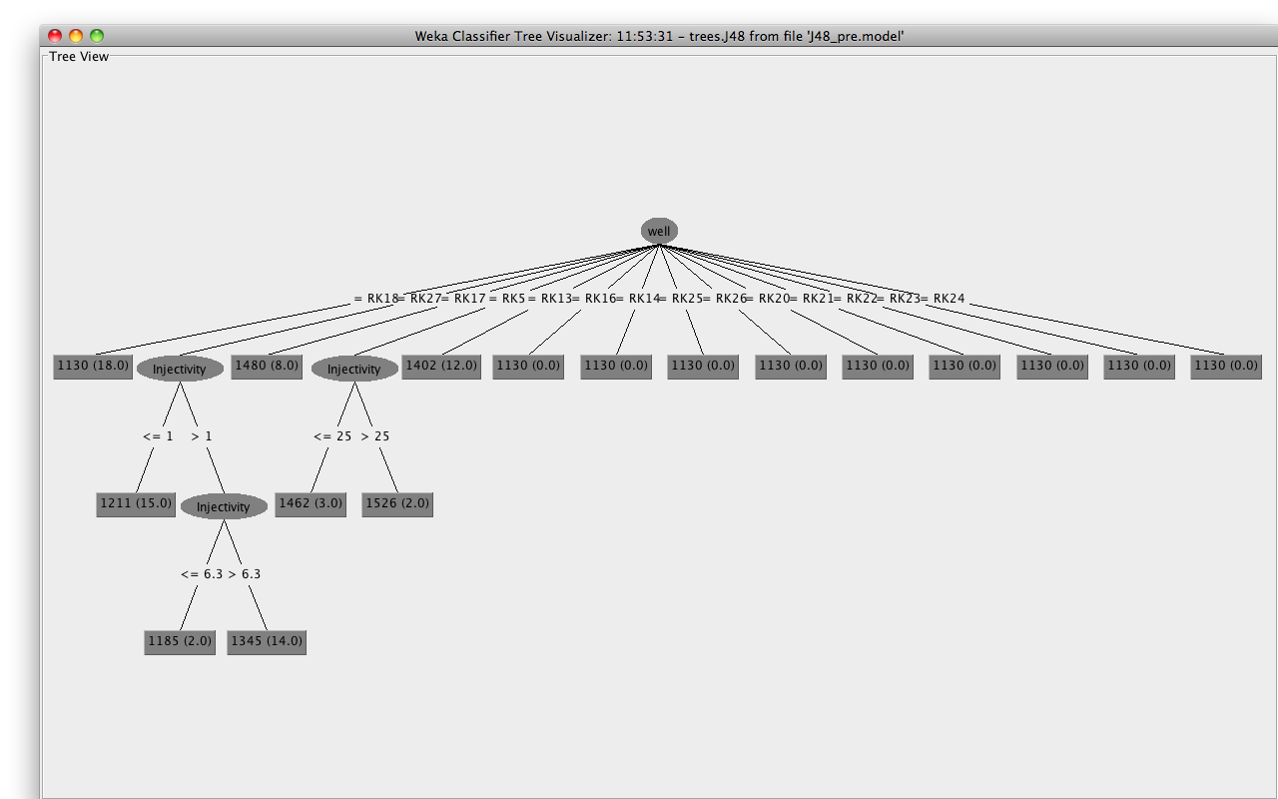

Figure 4. Visualization of classification tree from the J48 classification model.

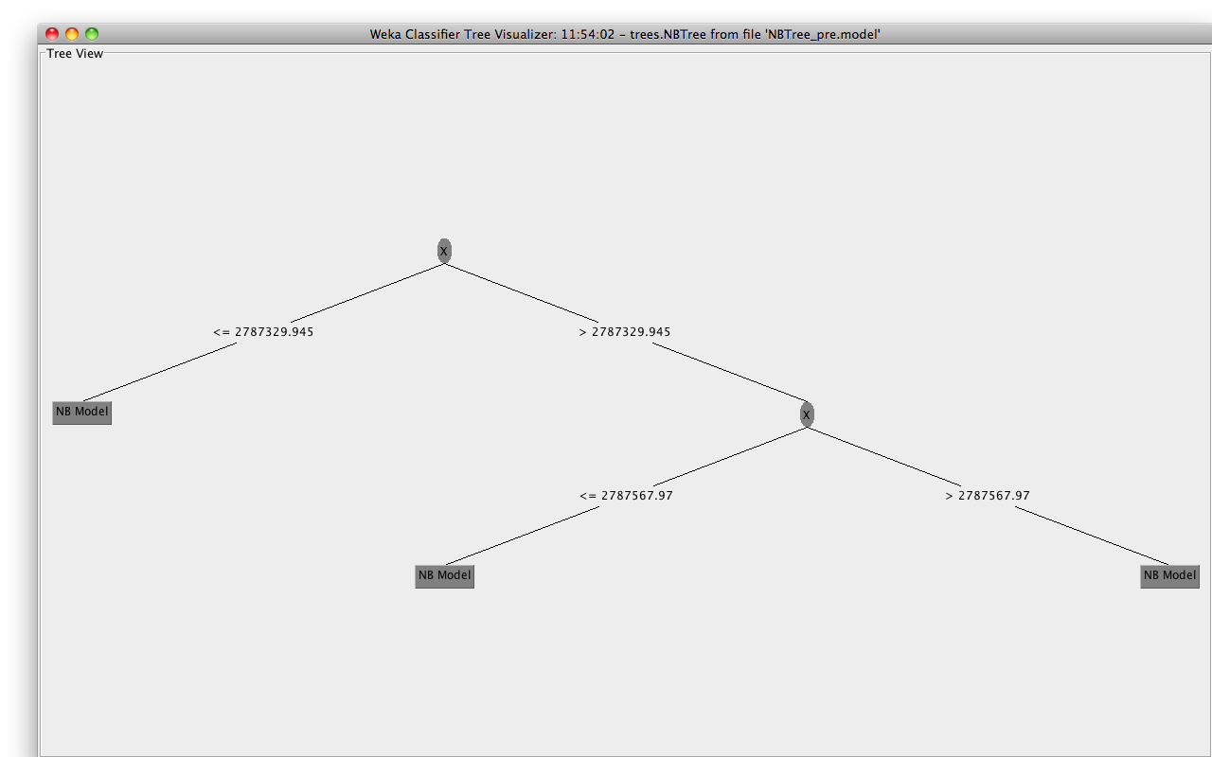

Figure 5. Visualization of classification tree from the NBtree classification model.

The resulting confusion matrices and predication probabilities does not tell the complete picture though, so predictions were combined into one table for comparison "Data Prediction Comparison.xlsx". There is a significant difference in the predicted results from the seven classification models per instance. This comparison is visualized in a circular plot showing the change in enthalpy values across each model for the instances, figure 6. The plot shows the variability between models especially predicted value changes at different instances. This maybe do to different weightings on the classes used for the predictions for each of models. If a particular model is focused on a certain class and that class value changes across an instance then the predicted values may change. Looking at the comparison of the prediction model values in the table and graph again only tell part of the story. This is a spacial problem so viewing the data in 3-D space is important to evaluating the prediction results. Visualization of those results is discussed in the next section.

Figure 6. Circular graph of model predictions over all predicted instances.

# 3-D Analysis

The prediction results from the seven models were visualized and compared to the measured enthalpy data in 3-D using Mining Visualization Systems (MVS) by C-TECH Inc. Figures 7-14 show the predicted data and the measured values along the well bore intervals . Seeing the predictions spatialy in 3-D reveals much more about the model results. The ANN, NBtree, and NNge models give the best results looking at the predicted values and there expected spatial distributions, figures 8, 12-13. The spatial distribution of the other models seem to be more random not geologically accurate. Figures 15-22 show cross sections through the interpolated models of the predicted data and measured values. The interpolated models were generated using the same grid and Kriging parameters for accurate comparisons. The cross sections have the same spatial locations in each figure for comparison. The same models, ANN, NBtree, and NNge give the best results for the full 3-D interpolation with the most geologically accurate values and spatial distribution figures 16, 20-21. Interpolation of the DT and Naive Bayes model gave unrealistic high values of enthalpy in shallow sections of the reservoir. Figures 23 -29 show cross sections through processed data values subtracting the interpolated nodal values from the predicted data sets from the interpolated nodal values for the measured data interpolation. The data match revealed a pattern of banding or higher relative difference of the measured data interpolation and the predicted data models. This is most likely due to the horizontally preferenced interpolation of the measured data values using the 3-D Kriging given the sparse data set. The predicted value data sets helped fill out the model and constrain the 3-D interpolation by the Kriging algorithm.

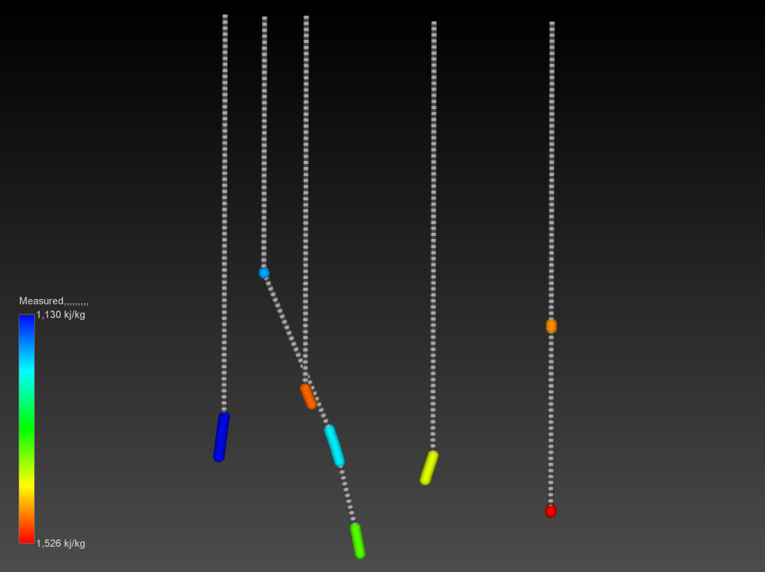

Figure 7. 3-D Visualization of the measured values along the well bores.

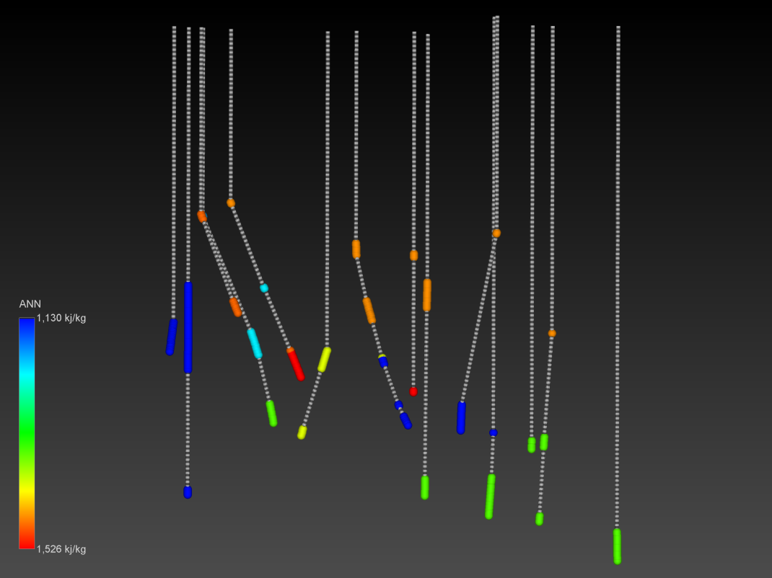

Figure 8. 3-D Visualization of the ANN predicted values along the well bores.

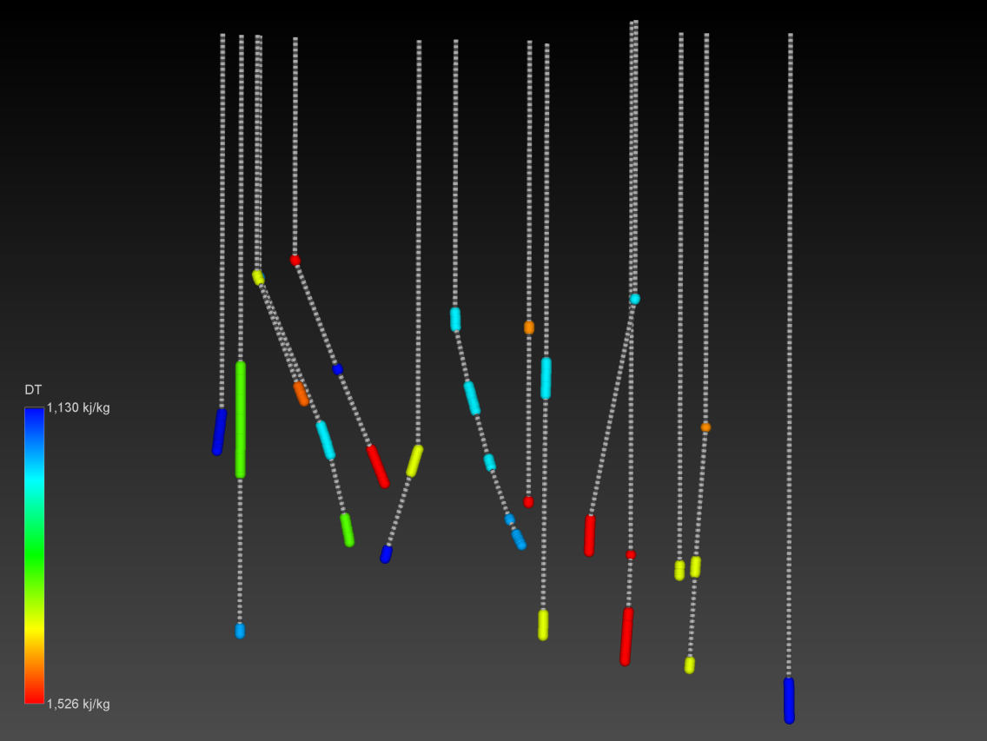

Figure 9. 3-D Visualization of the DT predicted values along the well bores.

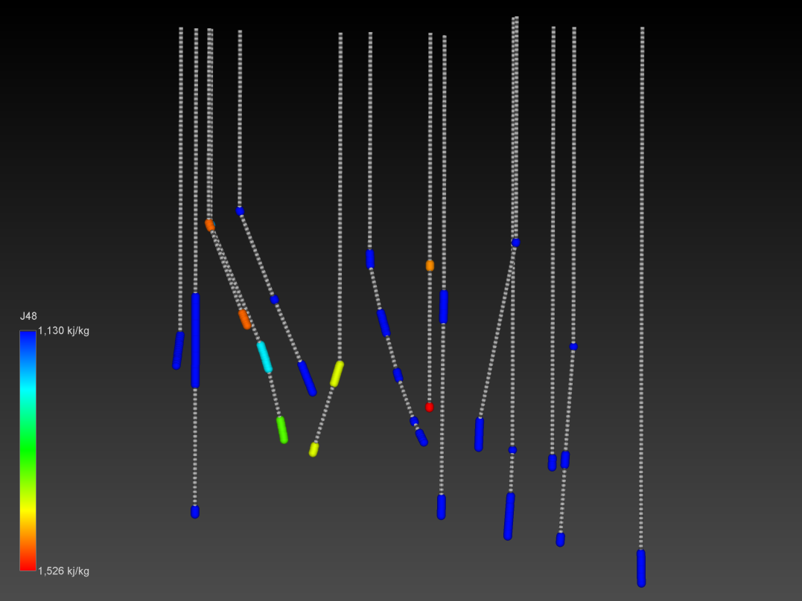

Figure 10. 3-D Visualization of the J48 predicted values along the well bores.

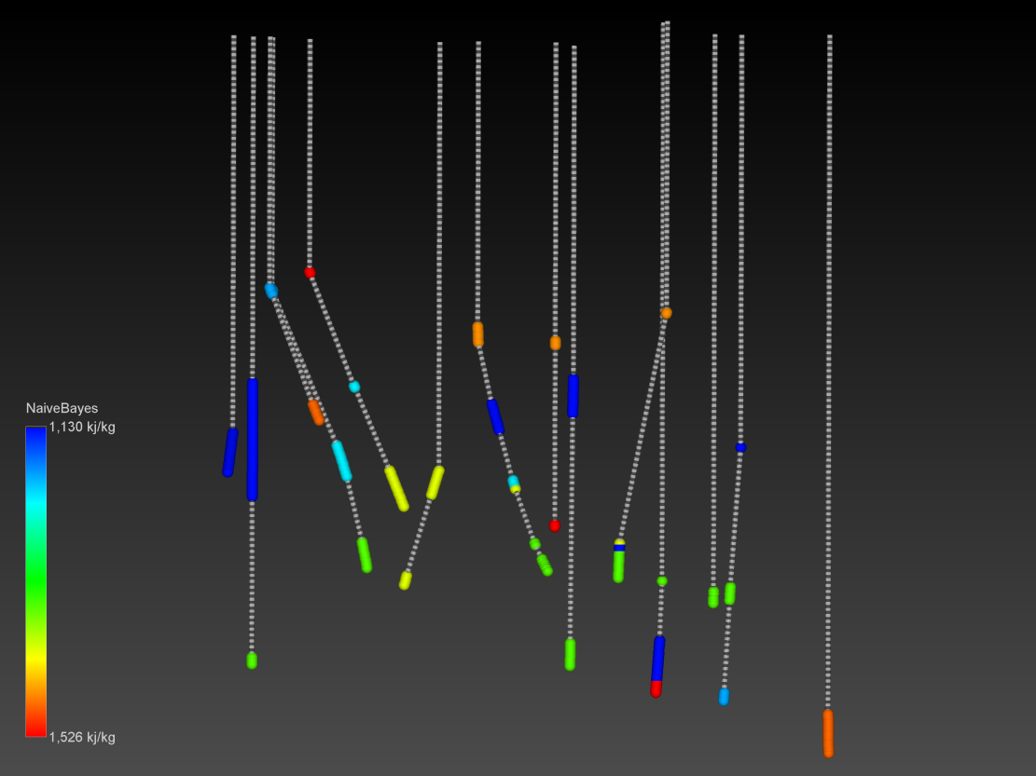

Figure 11. 3-D Visualization of the NaiveBayes predicted values along the well bores.

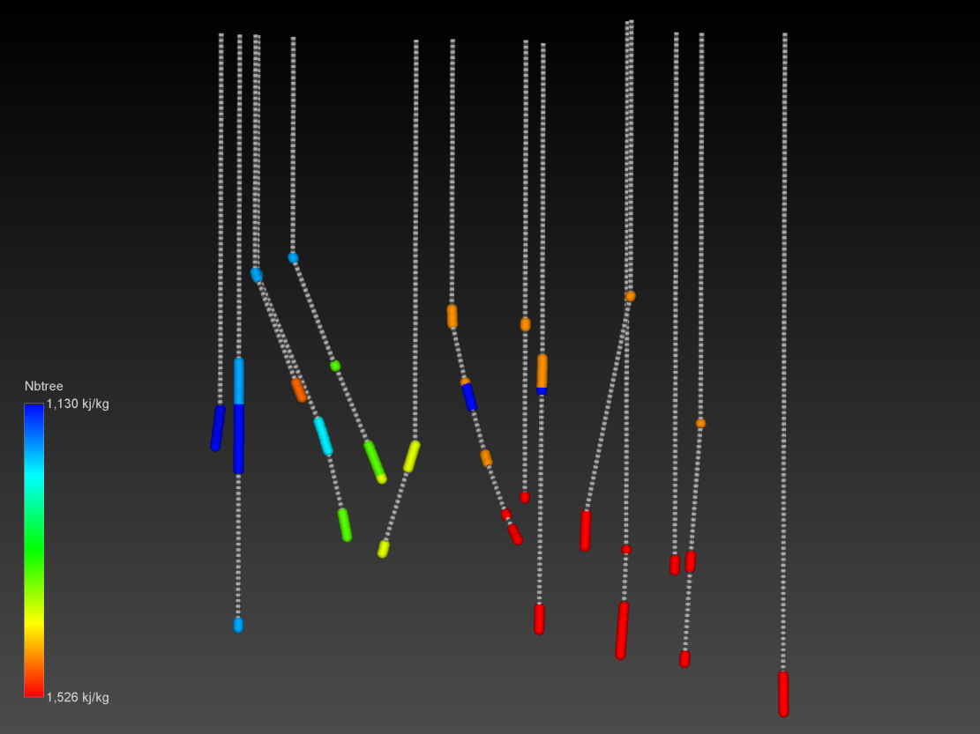

Figure 12. 3-D Visualization of the NBtree predicted values along the well bores.

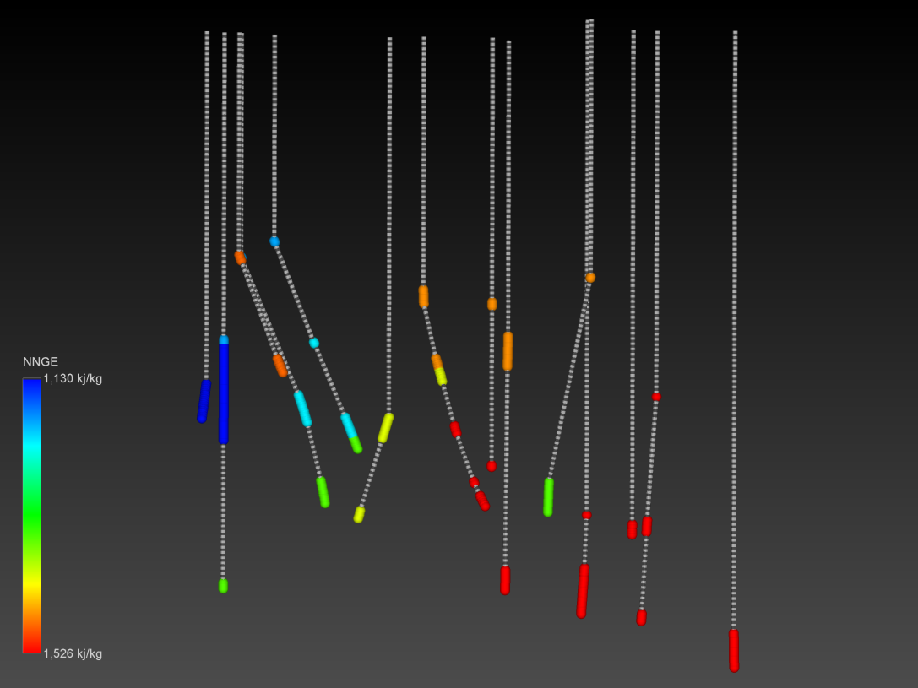

Figure 13. 3-D Visualization of the NNge predicted values along the well bores.

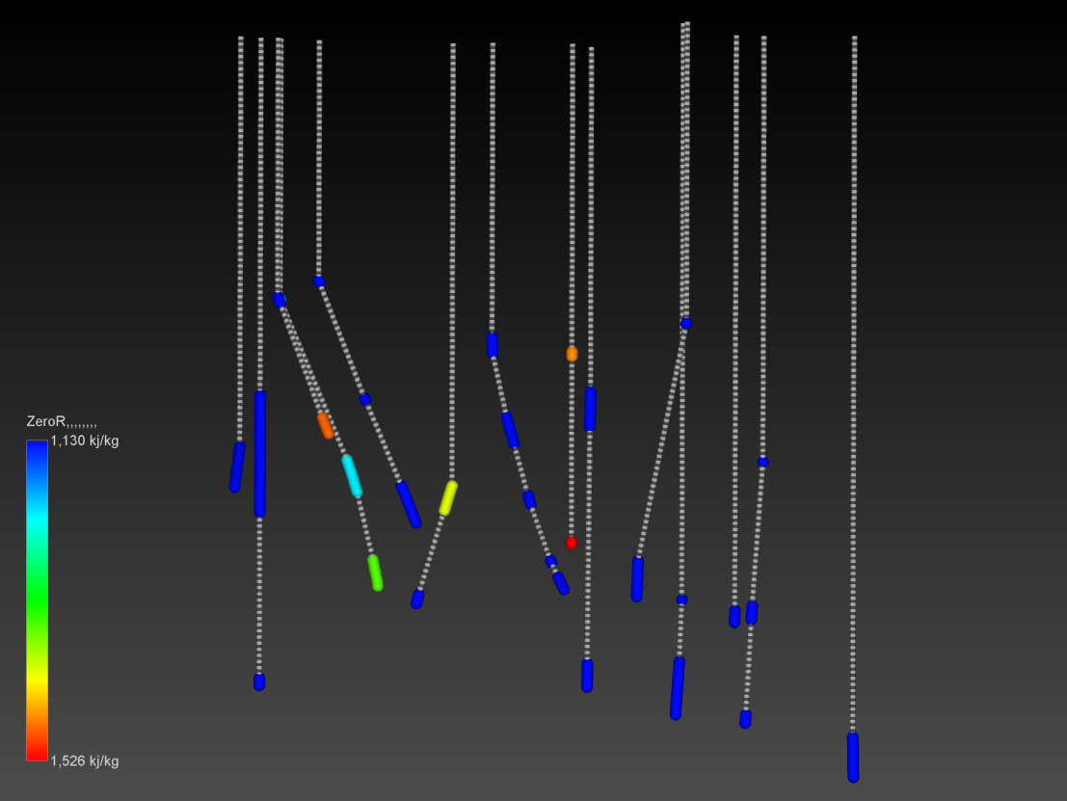

Figure 14. 3-D Visualization of the ZeroR predicted values along the well bores.

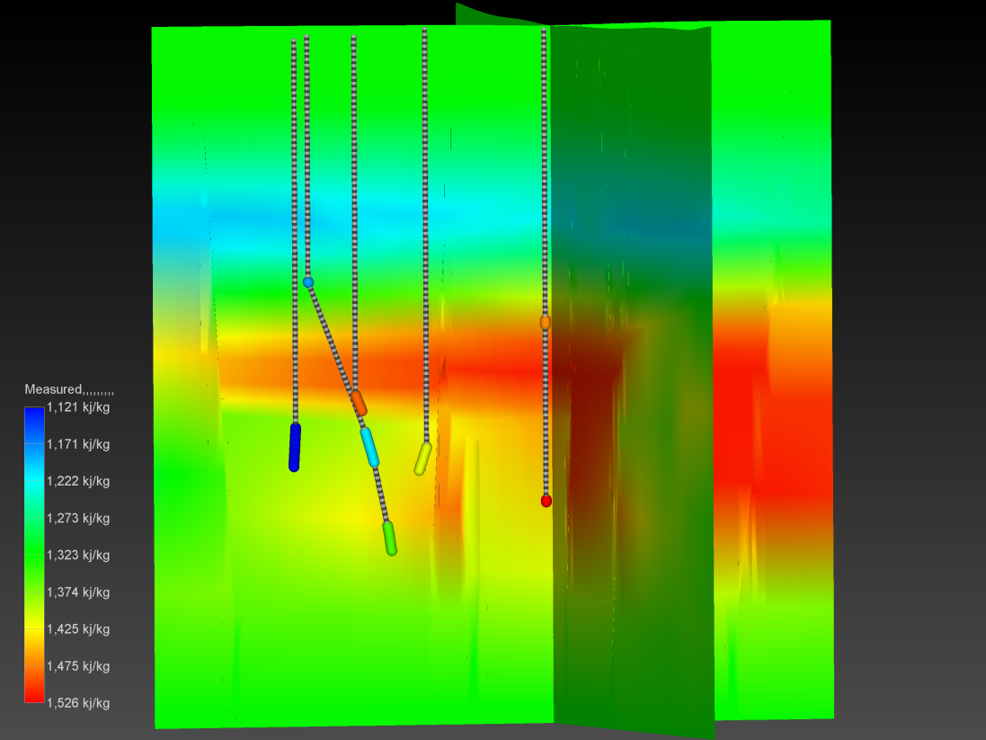

Figure 15. Cross Sections though interpolated measured enthalpy values.

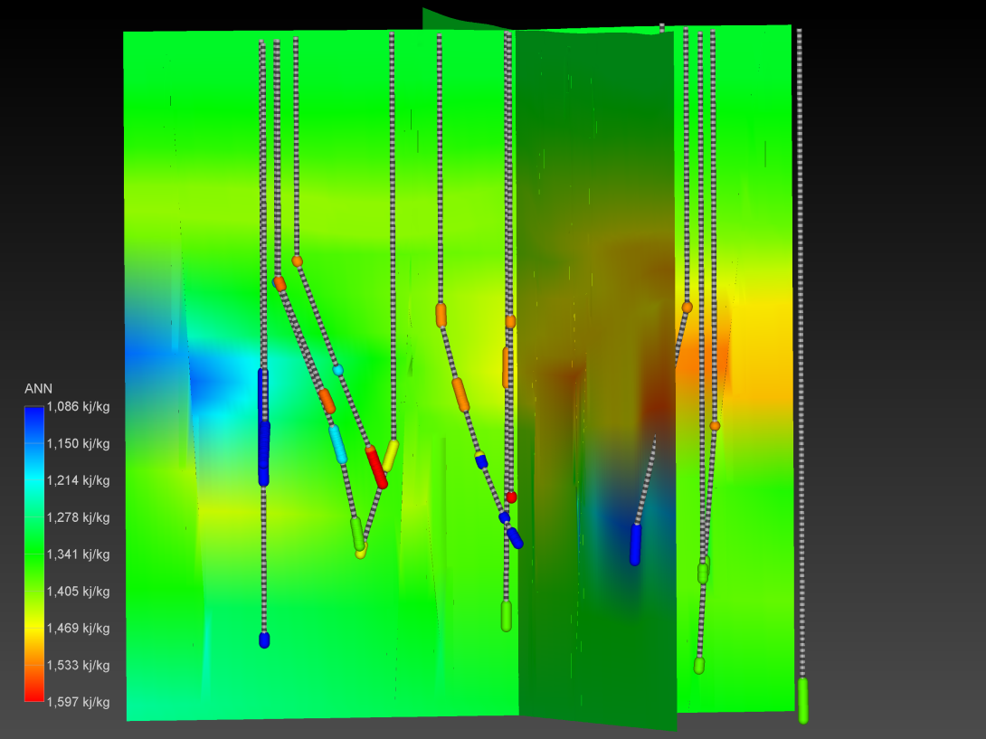

Figure 16. Cross Sections though interpolated predicted ANN enthalpy values.

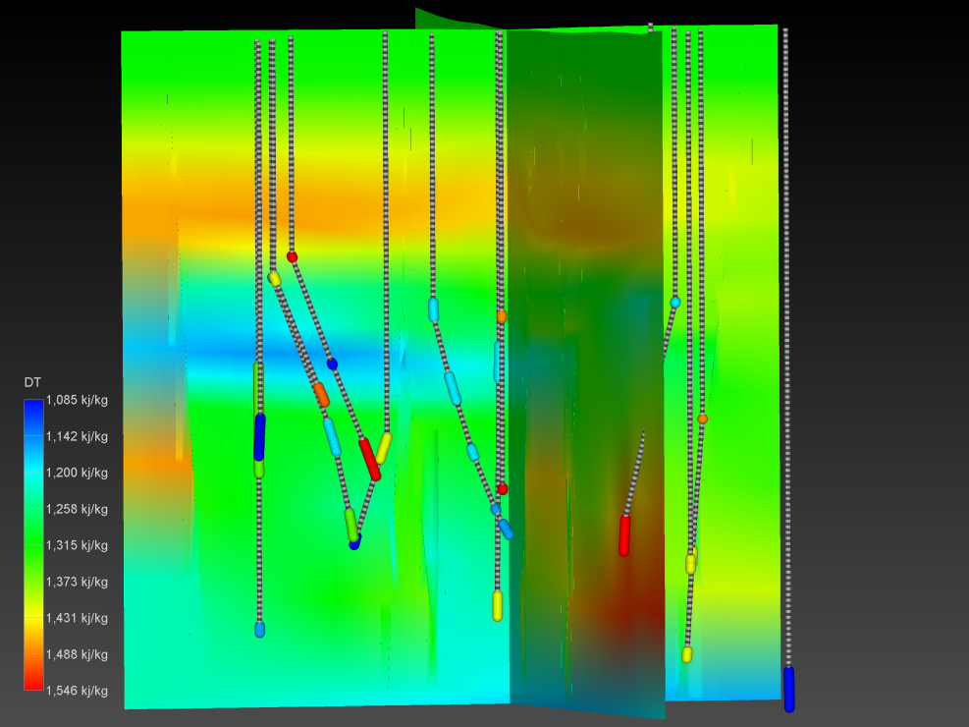

Figure 17. Cross Sections though interpolated predicted DT enthalpy values.

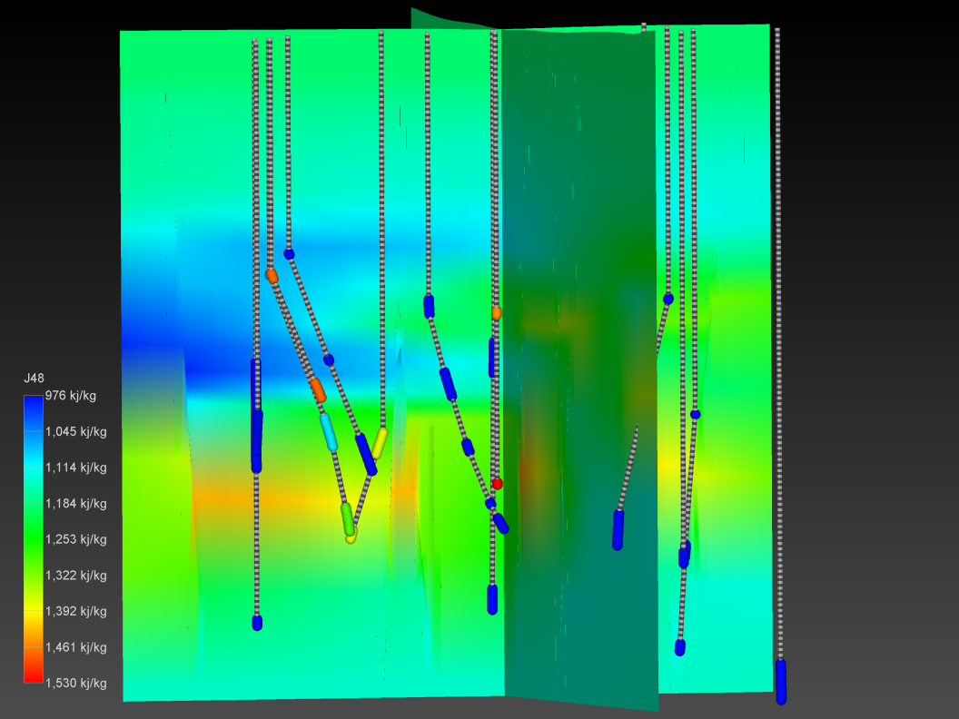

Figure 18. Cross Sections though interpolated predicted J48 enthalpy values.

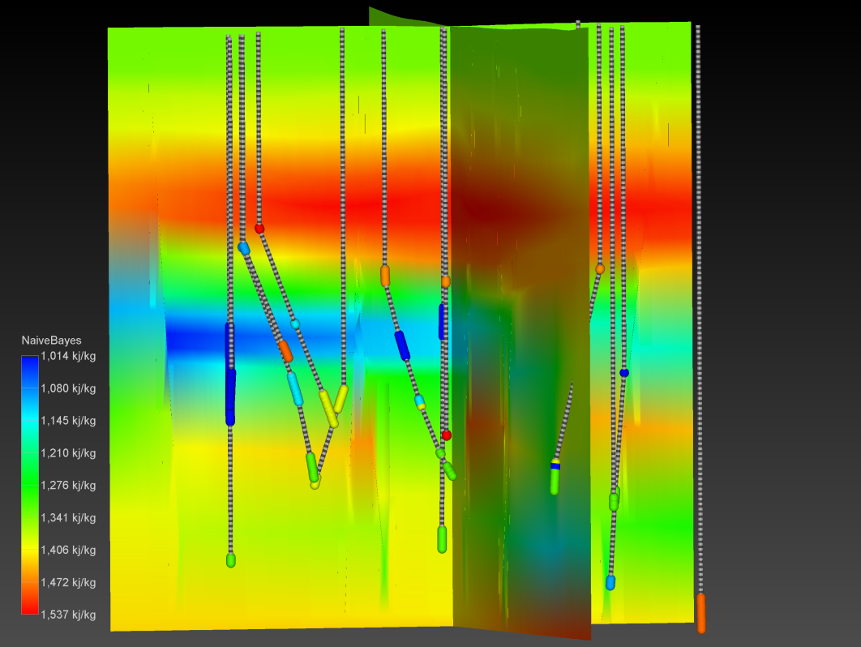

Figure 19. Cross Sections though interpolated predicted Naive Bayes enthalpy values.

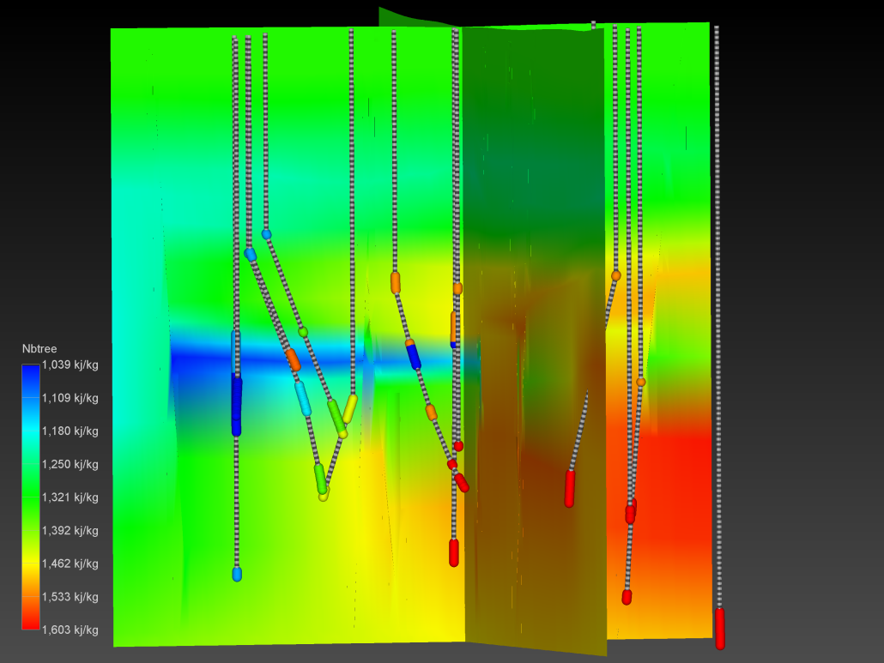

Figure 20. Cross Sections though interpolated predicted NBtree enthalpy values.

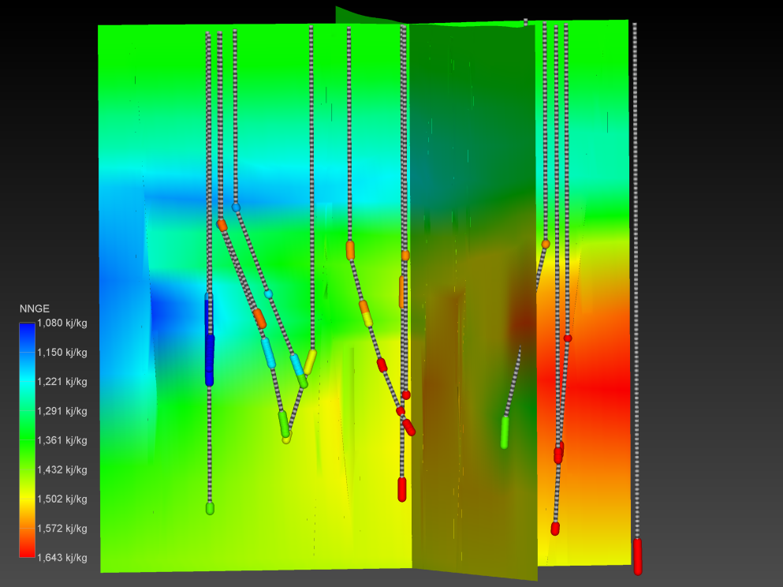

Figure 21. Cross Sections though interpolated predicted NNge enthalpy values.

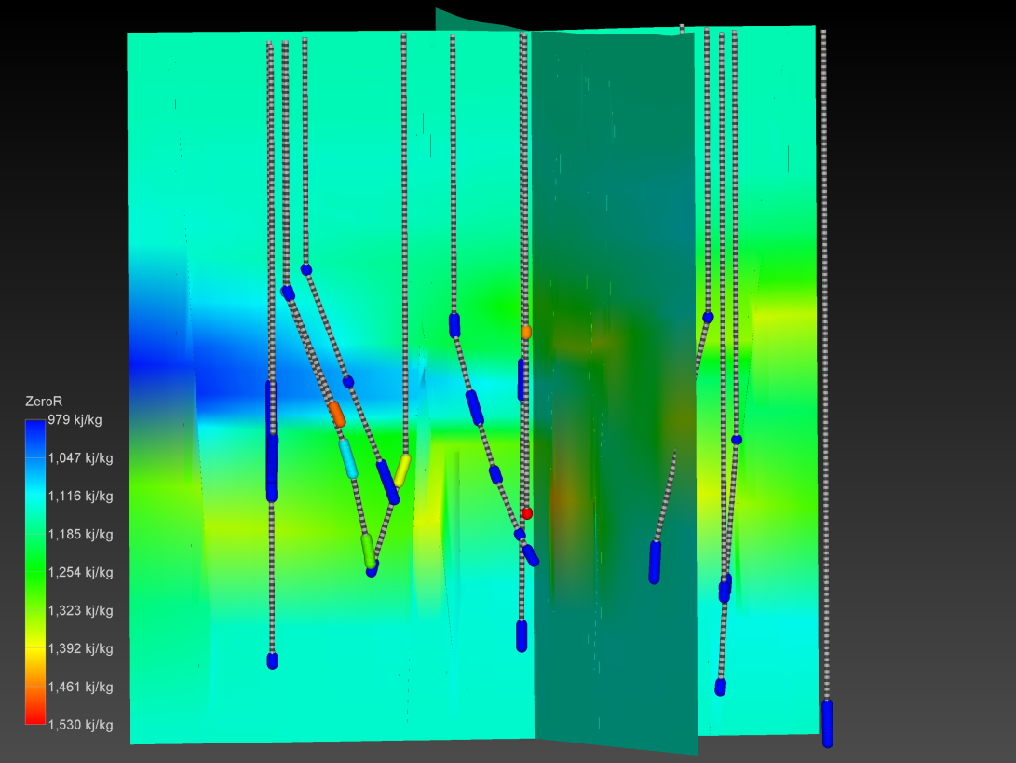

Figure 22. Cross Sections though interpolated predicted ZeroR enthalpy values.

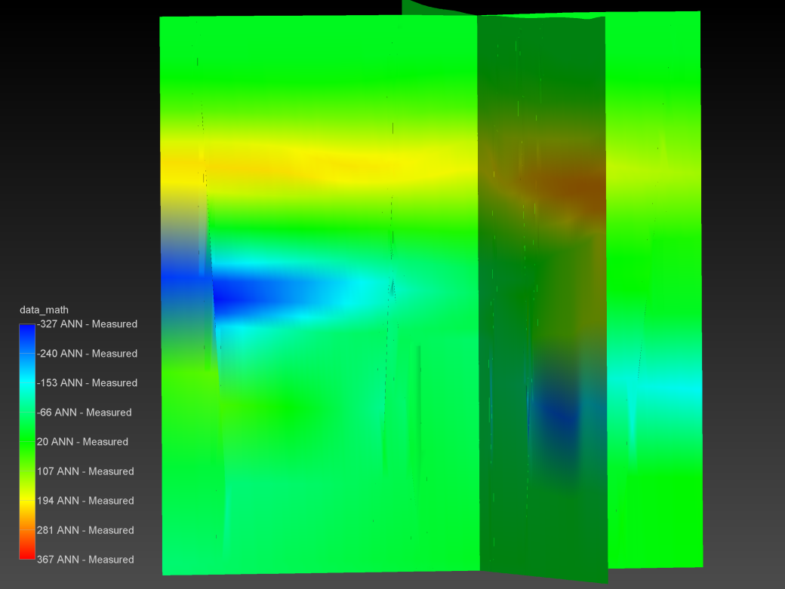

Figure 23. Cross Sections through results of subtraction interpolated measured enthalpy values from ANN values.

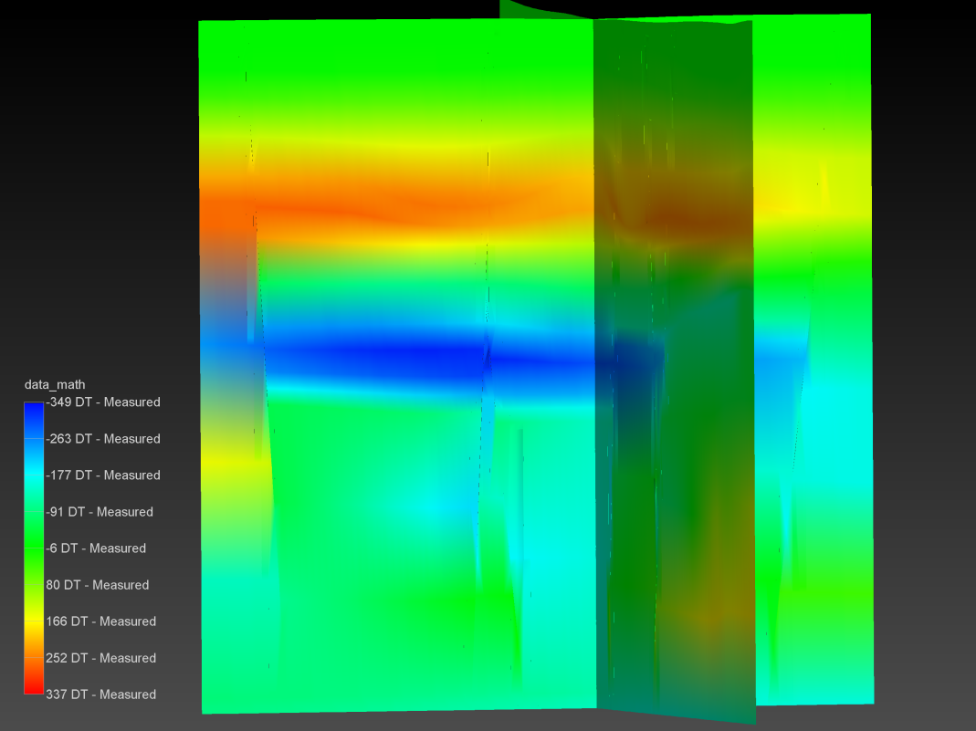

Figure 24. Cross Sections through results of subtraction interpolated measured enthalpy values from DT values.

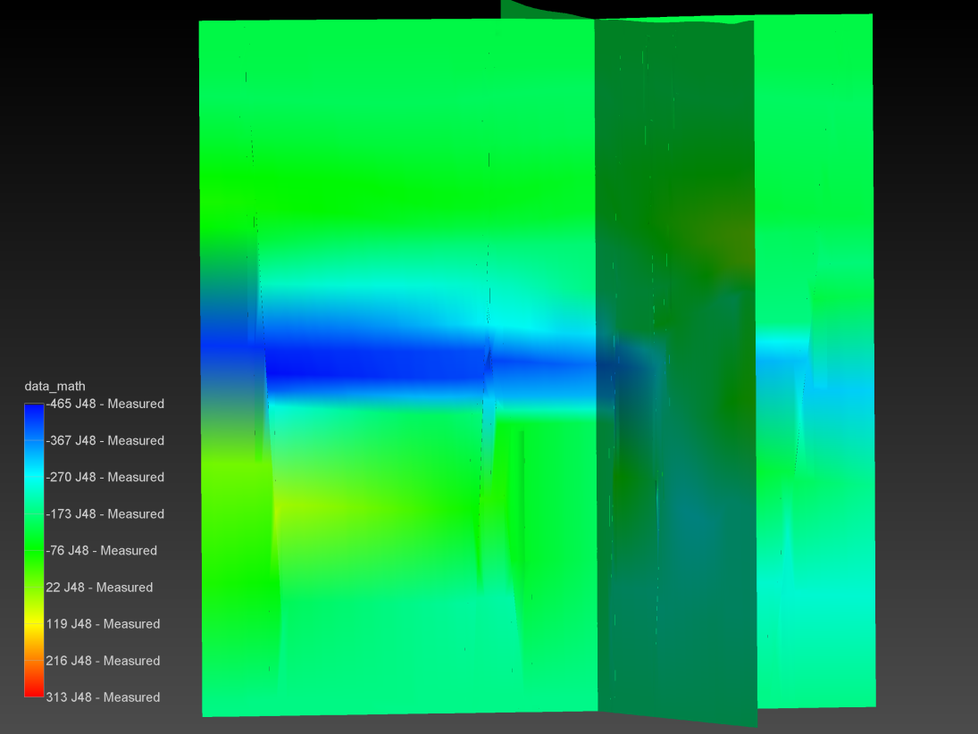

Figure 25. Cross Sections through results of subtraction interpolated measured enthalpy values from J48 values.

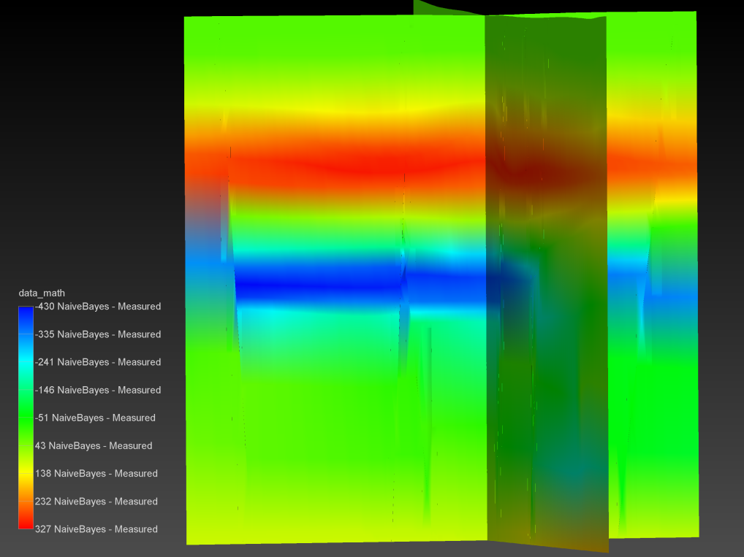

Figure 26. Cross Sections through results of subtraction interpolated measured enthalpy values from Naive Bayes values.

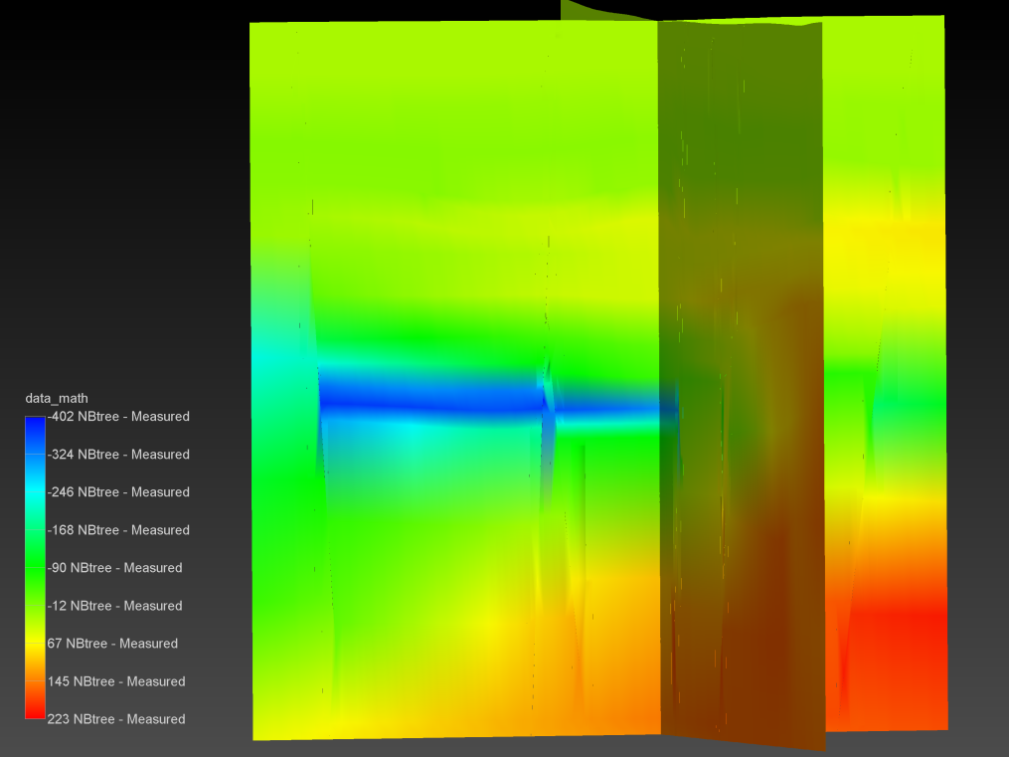

Figure 27. Cross Sections through results of subtraction interpolated measured enthalpy values from NBtree values.

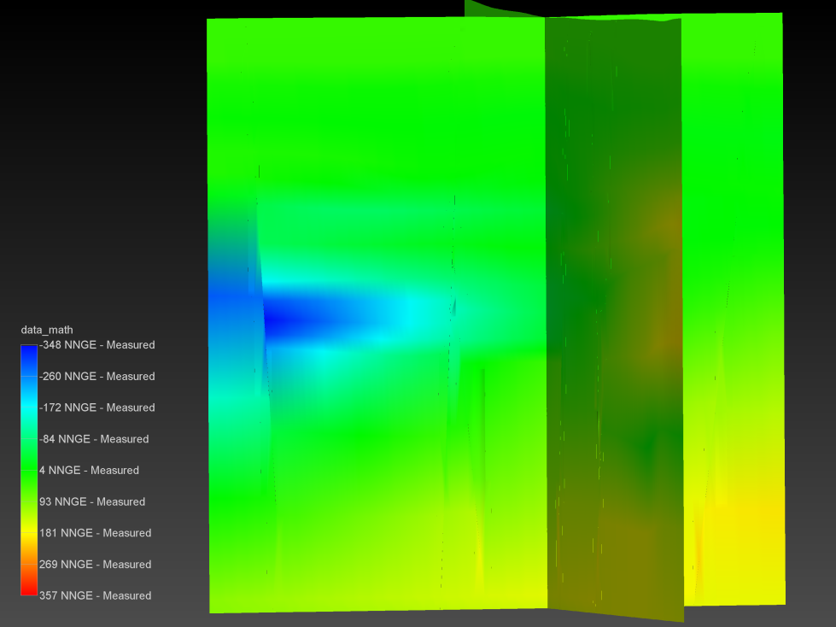

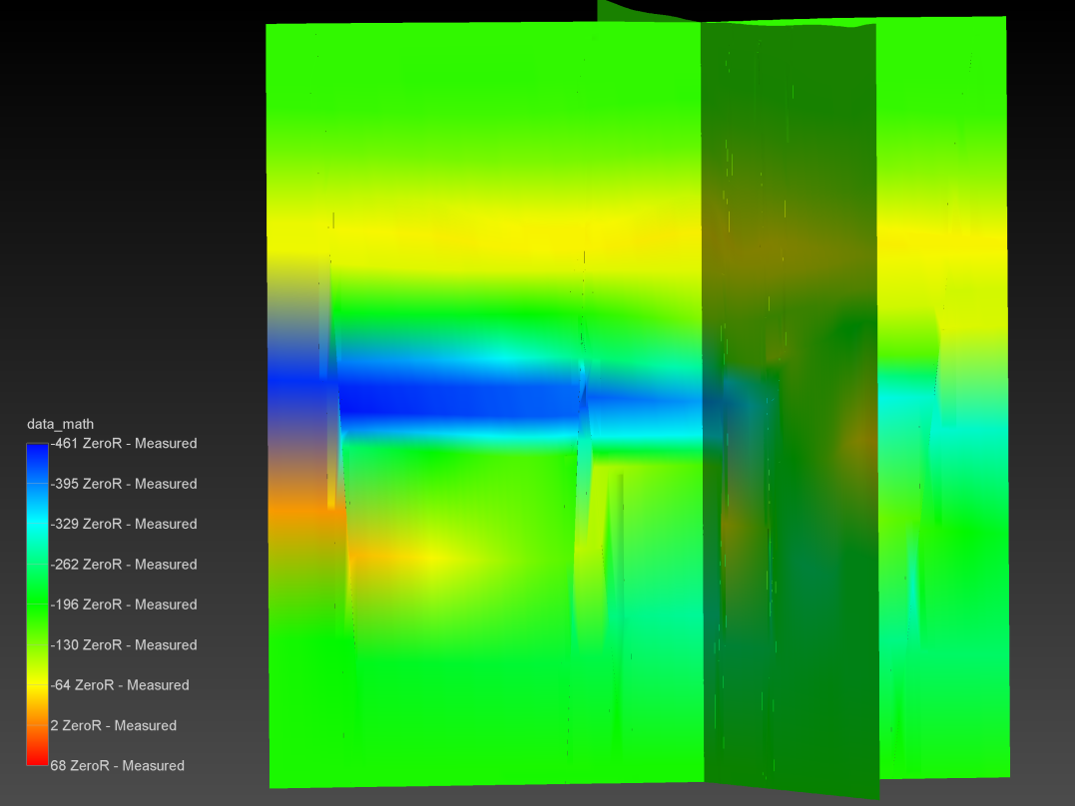Figure 28. Cross Sections through results of subtraction interpolated measured enthalpy values from NNge values.

Figure 29. Cross Sections through results of subtraction interpolated measured enthalpy values from ZeroR values.